Explanation

YES

SAMPLE OUTPUT

cdbda

abaca

SAMPLE INPUT

1 ≤ len(B) ≤ 1000000

1 ≤ len(A) ≤ 1000000

Constraints

For each test case, print YES if string A can be converted to string B, otherwise print NO.

Output format

Next line: String B

First line: String A

Input format

Your task is to determine if given strings A and B are compatible.

prefix xyz then we cannot increase the alphabetical value.

prefix xy then we can convert it to yx by increasing the alphabetical value by 1. But if we select the

characters in the prefix by the same valid amount. For example, if the string is xyz and we select the

·

Select a prefix from the string A (possibly empty), and increase the alphabetical value of all the

can be made equal by following this step any number of times:

Q1) Two strings A and B comprising of lower case English letters are compatible if they are equal or

Week 11

The string abaca can be converted to bcbda in one move and to cdbda in the next move.

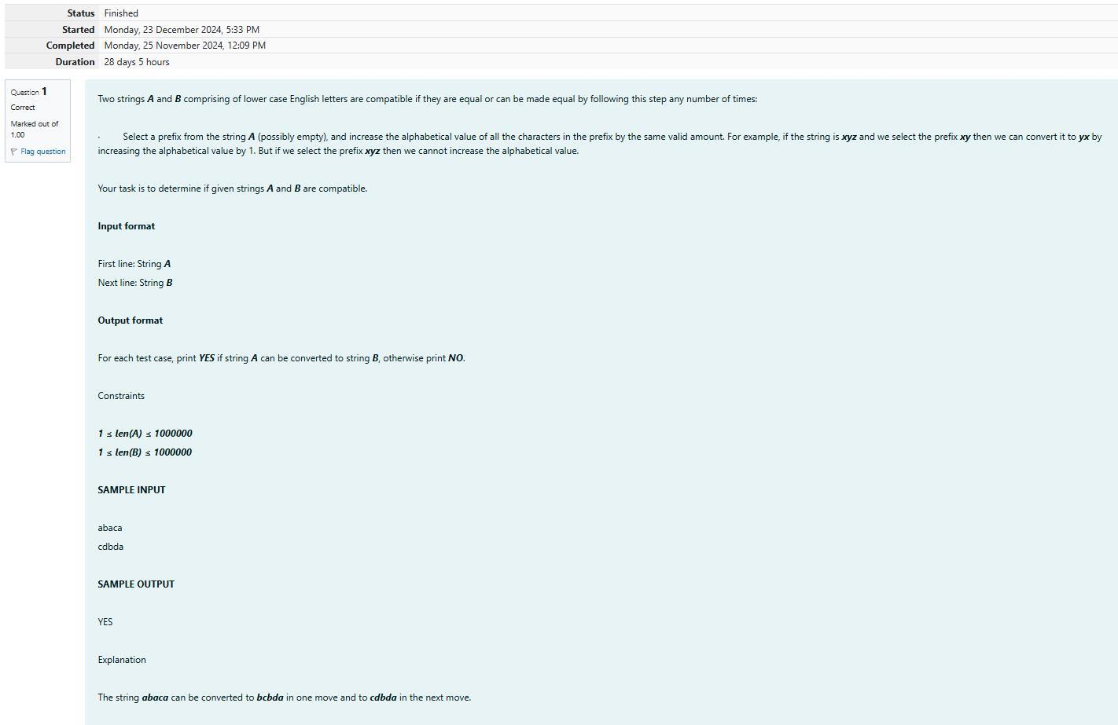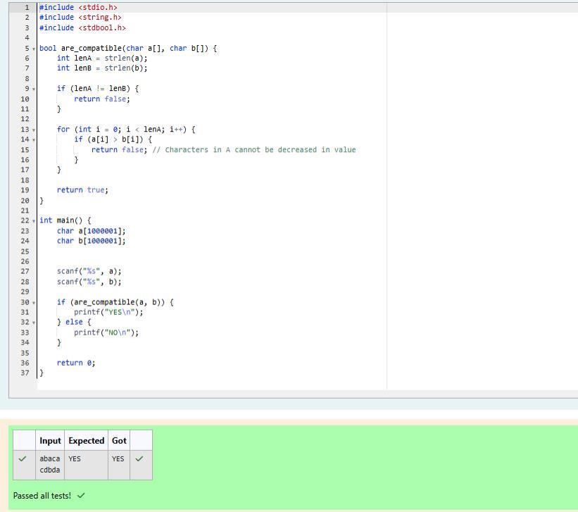

3 b

SAMPLE OUTPUT

cba

feg

def

abc

4

SAMPLE INPUT

1 ≤ N ≤ 100

CONSTRAINTS

ter.

The first and only line of output must contain the length of the correct password and its central let-

OUTPUT

and lesser than 14. All characters are lowercase letters of the English alphabet.

Each of the following N lines contains a single word, its length being an odd number greater than 2

The first line of input contains the integer N, the number of possible passwords.

INPUT

Note: The solution will be unique.

You have to print the length of Manny's password and it's middle character.

password both should be in the list.

odd. But Danny knows that Manny is a big fan of palindromes. So, his password and reverse of his

Q2) Danny has a possible list of passwords of Manny's facebook account. All passwords length is

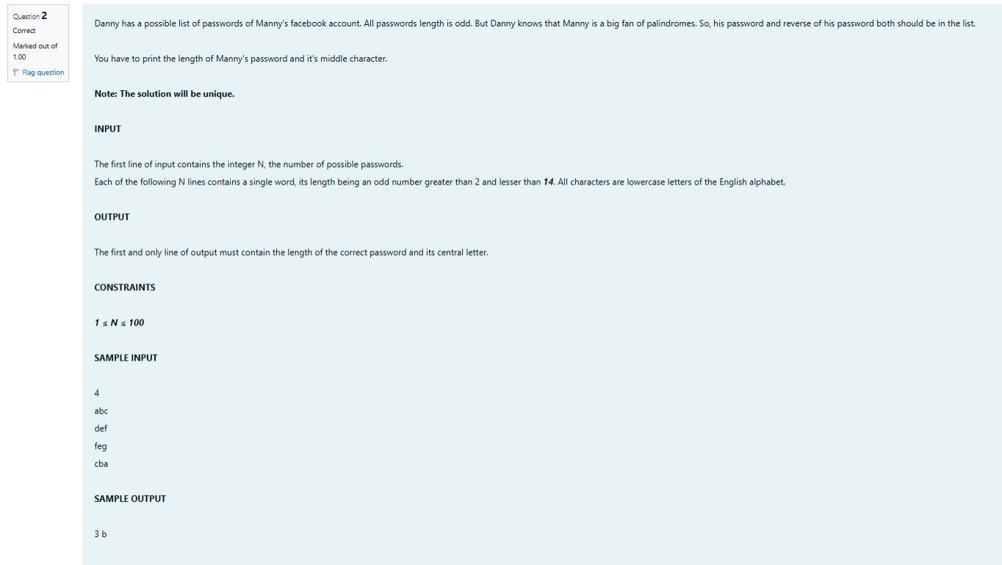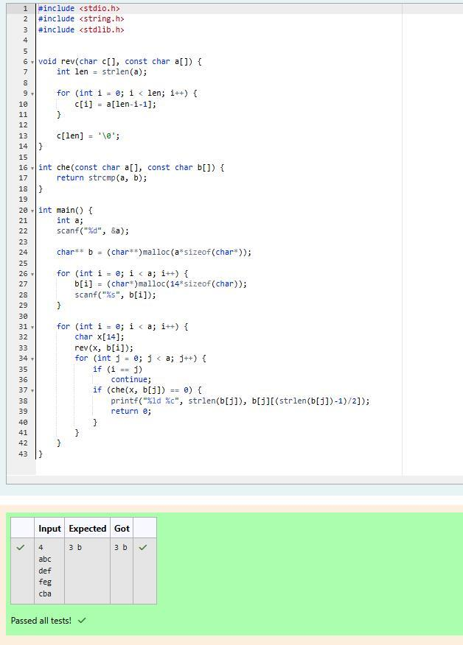

Explanation

Dominos

SAMPLE OUTPUT

Pizzapizza 49

Dominos 145

Pizzeria 108

3

SAMPLE INPUT

6

1 <= Points <= 10

5

1 <= N <= 10

Constraints:

Print the name of the restaurant that Joey should choose.

Output:

rant name has no spaces, all lowercase letters and will not be more than 20 characters.

Next N lines contain Name of Restaurant and Points awarded by Joey, separated by a space. Restau-

First line has N, the total number of restaurants.

Input:

dler's criteria. Can you help him out?

Joey has assigned points to all the restaurants, but can't figure out which restaurant satisfies Chan-

one with lexicographically smallest name.

rant having maximum points. If more than one restaurant has same points, Joey can choose the

Chandler suggests that Joey should give each restaurant some points, and then choose the restau-

should order. As always he asks Chandler for help.

tremely hungry and wants to eat pizza. But he is confused about the restaurant from where he

rants is deteriorating. The last few pizzas ordered by him did not taste good :(. Joey is feeling ex-

Q3) Joey loves to eat Pizza. But he is worried as the quality of pizza made by most of the restau-

Dominos has maximum points.

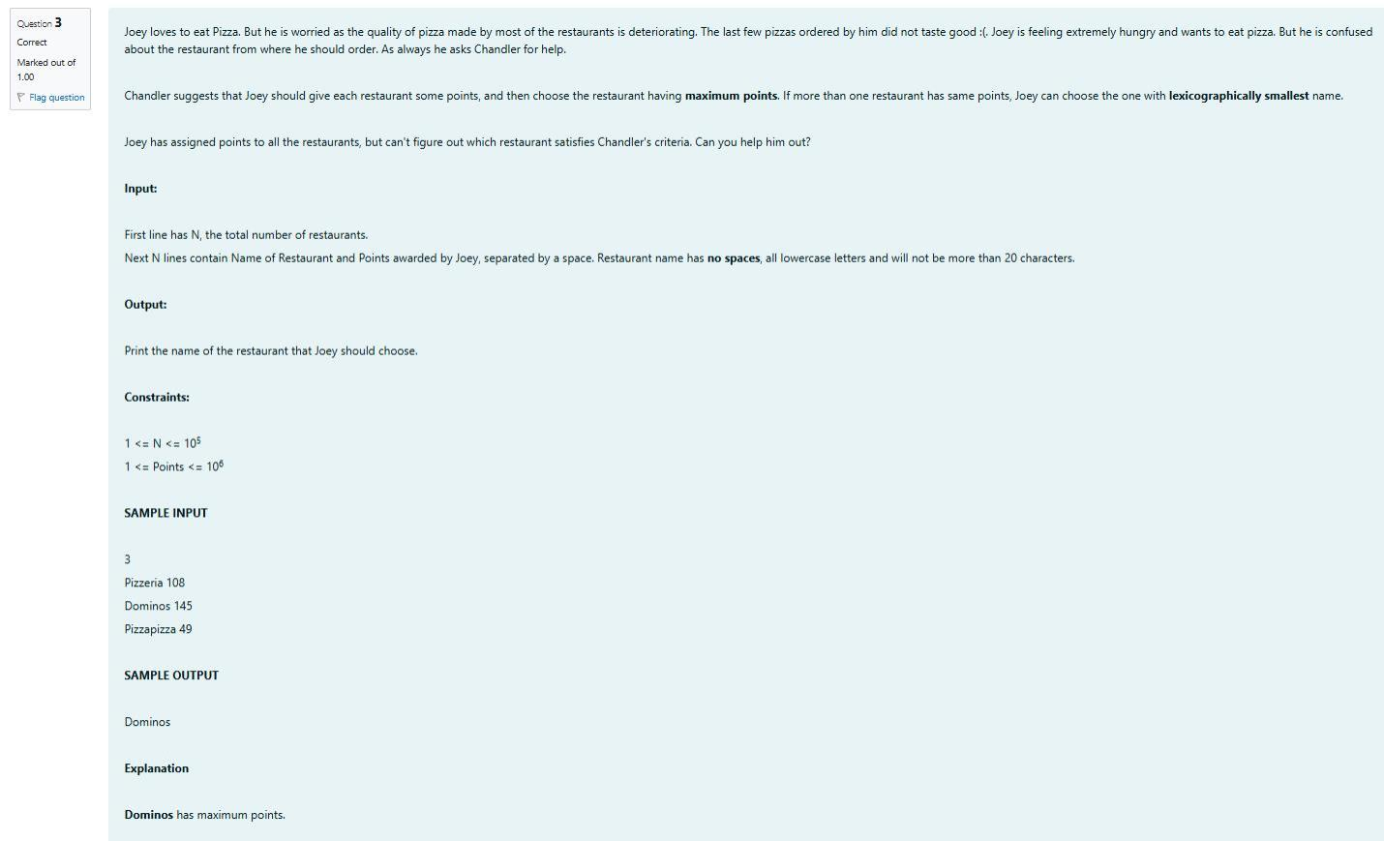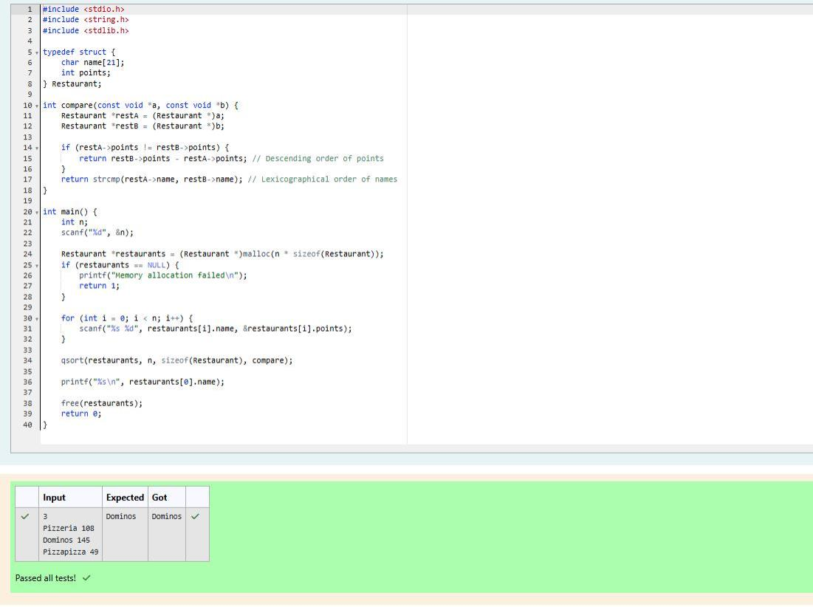

NO

NO

YES

SAMPLE OUTPUT

0123456.87

0123456789

1234567890

3

SAMPLE INPUT

5

sum of string length <= 10

3

1<= T <= 10

Constraints:

Note: Quotes are for clarity.

Print "YES" if it is valid mobile number else print "NO".

Output:

Next T line each representing "S" as described in in problem statement.

First line of input is T representing total number of test cases.

Input:

zeroes.

bile number is valid only if it is of length 10 , consists of numeric values and it shouldn't have prefix

You are given a string "S" and you have to determine whether it is Valid mobile number or not. Mo-

bers.

his crush number only if he has valid set of mobile numbers. Help him to determine the valid num-

of them are valid and some of them are invalid. Bechan Chacha has special power that he can pick

Q4) These days Bechan Chacha is depressed because his crush gave him list of mobile number some

